The Super Stock Screener Ranking System

# The Super Stock Screener Ranking System

**The Model**

The ranking system uses a factor-based model to grade stocks. The factors are primarily financial variables and ratios (i.e. Sales / Inventory). However, the ranking system also includes price-based technical criteria. Importantly, each factor in our model has historically had a strong correlation with future stock returns. For example, one of the model inputs is operating cash flow. We have found that stocks with high operating cash flow typically outperform those with low or negative operating cash flow. Below is a sample of several financial variables and ratios that are input into the model:

* Current Assets  
* Current Liabilities  
* Operating Cash Flow  
* Sales  
* Gross Margin  
* Net Income  
* Return on Equity  
* Return on Assets

Each stock in our database (over 7000) is evaluated against all the factors in the model. Stocks receive a score based on how well they measure against each factor. The ranking system’s recommendations depend on the strength of each stock’s overall model score. There are five possible recommendations:

1. Strong Buy  
2. Buy  
3. Hold  
4. Sell  
5. Strong Sell

Companies receiving the highest grade are labeled as Strong Buys. Conversely, those with the lowest scores are Strong Sells.

<http://www.superstockscreener.com/blog/2007/09/admin/the-super-stock-screener-ranking-system/>

# Financial Factory Ranking

The FF Stock Rank is a stock ranking system that ranks listed US companies/stocks along quality and sentiment dimensions using a multi-factor scoring methodology. FF Stock Rank is a numerical ranking system that uses quantifiable factors. There are two ranking models:

FF Quality Rank. This ranking creates a composite score for every company based on 'quality' factors. High scores are given solid companies with strong balance sheets and financial statements. If you, like Warren Buffett, think that 'value investing' is the most profitable way of making stock investments - FF Quality Rank is for you.

FF Sentiment Rank. This ranking creates a composite score for every company based on 'sentiment' factors. High scores are given companies that are experiencing good sentiment/momentum, i.e. companies that are in favor in the investment community, companies that investors and analysts approve of. If you like 'momentum investing' - FF Sentiment Rank is the choice.

The stocks are assigned ranks from #1 to #5, from 'Strong Buy' to 'Strong Sell', based on the composite scores.

<http://www.financialfactory.com/ranking.asp>

# Zack Ranking

<http://www.zacks.com/help/zrankquickguide.php?p=3>

The Zacks Rank is a quantitative process that is run daily on computers. Which means it can change rapidly in this fast paced world of ours.

So it is quite possible that today one of your stocks is a #1 Rank. Tomorrow it becomes a #2 or lower. And then amazingly pops back to a #1 Rank shortly thereafter. That is just the nature of the beast and why we highly recommend that you stick to the 4 week rebalancing process to not make unnecessary or unprofitable changes to your portfolio

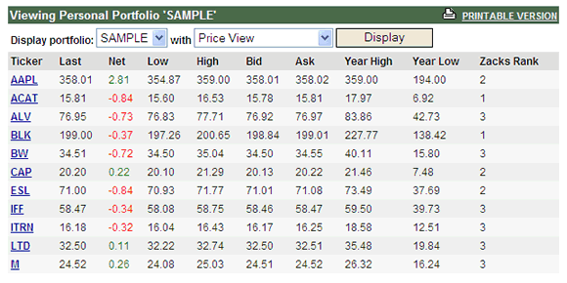

<http://www.slideshare.net/riturajvasant/stock-ranking-a-neural-networks-approach-presentation>

<http://www.investopedia.com/articles/trading/08/relative-strength.asp#axzz1YTl6s39o>

Tim các cổ phiếu có dấu hiệu làm giá

- các cổ phiếu tăng trần lien tiếp

- các cổ phiếu có khối lượng bất thường: gấp 3 ngày thường

- các cổ phiếu có xu hướng giá bất thường: thay đổi đột ngột trong nhiều ngày lien tiếp